|  |  |
| --- | --- |
| **Application No:** | DA2019/00061 |
| **Land:** | Lot 1 DP 204077 |
| **Property Address:** | 11-17 Mosbri Crescent, The Hill NSW 2300 |
| **Proposed Development:** | Residential accommodation, strata subdivision, earthworks and demolition – residential accommodation comprising three residential flat buildings (161 units) and multi-dwelling housing (11 two-storey dwellings), strata subdivision (172 lots), car parking, tree removal, landscaping, access and pathways, associated site works and services, earthworks, mine grouting works (including associated temporary plant and equipment) and staged demolition of existing structures |

**SCHEDULE 1**

**APPROVED DOCUMENTATION**

1. The development is to be implemented in accordance with the plans and supporting documents set out in the following table except where modified by any conditions of this consent.

|  |  |  |  |
| --- | --- | --- | --- |
| **Plan No / Supporting Document** | **Reference / Version** | **Prepared by** | **Dated** |
| SEPP 65 Design Verification Statement | - | Marchese Partners | 13/05/2022 |
| Site Plan / DA1.03 | Job 17114  Revision D | Marchese Partners | 16/05/2022 |
| Demolition Plan / DA1.05 | Job 17114  Revision B | Marchese Partners | 16/05/2022 |
| Demolition Staging Plan / DA1.06 | Job 17114  Revision A | Marchese Partners | 16/12/2021 |
| Lower Ground Floor Plan / DA2.01 | Job 17114  Revision H | Marchese Partners | 16/05/2022 |
| Ground Floor Plan / DA2.02 | Job 17114  Revision I | Marchese Partners | 16/05/2022 |
| Level 1 Floor Plan / DA2.03 | Job 17114  Revision H | Marchese Partners | 16/05/2022 |
| Level 2 Floor Plan / DA2.04 | Job 17114  Revision I | Marchese Partners | 16/05/2022 |
| Level 3 Floor Plan / DA2.05 | Job 17114  Revision H | Marchese Partners | 16/05/2022 |
| Level 4 Floor Plan / DA2.06 | Job 17114  Revision H | Marchese Partners | 16/05/2022 |
| Level 5 Floor Plan / DA2.07 | Job 17114  Revision H | Marchese Partners | 16/05/2022 |
| Level 6 Floor Plan / DA2.08 | Job 17114  Revision H | Marchese Partners | 16/05/2022 |
| Level 7 Floor Plan / DA2.09 | Job 17114  Revision H | Marchese Partners | 16/05/2022 |
| Level 8 Floor Plan / DA2.10 | Job 17114  Revision H | Marchese Partners | 16/05/2022 |
| Roof Floor Plan / DA2.11 | Job 17114  Revision I | Marchese Partners | 16/05/2022 |
| Site Sections & Elevations 01 – Mosbri Cres Town Houses / DA3.01 | Job 17114  Revision F | Marchese Partners | 16/05/2022 |
| Site Sections & Elevations 02 / DA3.02 | Job 17114  Revision I | Marchese Partners | 16/05/2022 |
| Site Elevation & Elevation 03 / DA3.03 | Job 17114  Revision H | Marchese Partners | 16/05/2022 |
| Site Sections & Elevations 04 / DA3.04 | Job 17114  Revision H | Marchese Partners | 16/05/2022 |
| Site Sections & Elevations 05 / DA3.05 | Job 17114  Revision G | Marchese Partners | 16/12/2021 |
| Site Sections & Elevations 06 / DA3.06 | Job 17114  Revision G | Marchese Partners | 16/12/2021 |
| Section AA / DA3.07 | Job 17114  Revision F | Marchese Partners | 16/12/2021 |
| Site Elevations (West & North) / DA3.11 | Job 17114  Revision A | Marchese Partners | 16/12/2021 |
| Site Elevations (East & South) / DA3.12 | Job 17114  Revision A | Marchese Partners | 16/12/2021 |
| Exterior Finishes – Building A / DA7.20 | Job 17114  Revision E | Marchese Partners | 16/05/2022 |
| Exterior Finishes - Mosbri Cres Town Houses / DA7.21 | Job 17114  Revision E | Marchese Partners | 16/12/2021 |
| Exterior Finishes - Building B & C / DA7.23 | Job 17114  Revision F | Marchese Partners | 16/12/2021 |
| Community Pavilion / DA4.01 | Job 17114  Revision C | Marchese Partners | 16/12/2021 |
| Townhouse Type A (MC) 3 Bedroom / DA4.11 | Job 17114  Revision A | Marchese Partners | 10/12/2021 |
| Townhouse Type B (MC) 3 Bedroom / DA4.12 | Job 17114  Revision A | Marchese Partners | 10/12/2021 |
| Townhouse Type C (MC) 3 Bedroom / DA4.13 | Job 17114  Revision A | Marchese Partners | 10/12/2021 |
| Townhouse Type D (MC) 3 Bedroom / DA4/14 | Job 17114  Revision A | Marchese Partners | 10/12/2021 |
| Townhouse Type C1 3 Bedroom / DA4.15 | Job 17114  Revision B | Marchese Partners | 21/04/2022 |
| Townhouse Type C2 3 Bedroom / DA4.16 | Job 17114  Revision C | Marchese Partners | 16/05/2022 |
| Townhouse Type C3 3 Bedroom / DA4.17 | Job 17114  Revision C | Marchese Partners | 16/05/2022 |
| Townhouse Type D1 1 Bedroom / DA4.18 | Job 17114  Revision C | Marchese Partners | 16/05/2022 |
| Townhouse Type D2 1 Bedroom / DA4.19 | Job 17114  Revision C | Marchese Partners | 16/05/2022 |
| Townhouse Type D3 1 Bedroom / DA4.20 | Job 17114  Revision C | Marchese Partners | 16/05/2022 |
| Townhouse Type E 2 Bedroom / DA4.21A | Job 17114  Revision C | Marchese Partners | 13/05/2022 |
| Townhouse Type E 2 Bedroom / DA4.21B | Job 17114  Revision C | Marchese Partners | 16/05/2022 |
| Townhouse Type F 1 Bedroom / DA4.22 | Job 17114  Revision C | Marchese Partners | 16/05/2022 |
| Townhouse Type G 2 Bedroom / DA4.23 | Job 17114  Revision C | Marchese Partners | 16/05/2022 |
| Townhouse Type H 3 Bedroom / DA4.24 | Job 17114  Revision C | Marchese Partners | 16/05/2022 |
| Townhouse Type I 3 Bedroom / DA4.25 | Job 17114  Revision C | Marchese Partners | 16/05/2022 |
| Townhouse Type I 3 Bedroom / DA4.25 | Job 17114  Revision C | Marchese Partners | 16/05/2022 |
| Townhouse Type J 2 Bedroom / DA4.26 | Job 17114  Revision C | Marchese Partners | 16/05/2022 |
| Unit Type A1 1 Bedroom / DA4.27 | Job 17114  Revision C | Marchese Partners | 16/05/2022 |
| Unit Type A2 2 Bedroom / DA4.28 | Job 17114  Revision C | Marchese Partners | 16/05/2022 |
| Unit Type B1 2 Bedroom / DA4.29 | Job 17114  Revision B | Marchese Partners | 16/05/2022 |
| Unit Type B2 2 Bedroom / DA4.30 | Job 17114  Revision B | Marchese Partners | 22/04/2021 |
| Unit Type C 2 Bedroom / DA4.31 | Job 17114  Revision B | Marchese Partners | 22/04/2021 |
| Unit Type D1 2 Bedroom / DA4.32 | Job 17114  Revision B | Marchese Partners | 22/04/2021 |
| Unit Type D2 2 Bedroom / DA4.33 | Job 17114  Revision B | Marchese Partners | 22/04/2021 |
| Unit Type E 2 Bedroom / DA4.34A | Job 17114  Revision C | Marchese Partners | 16/05/2022 |
| Unit Type E2 2 Bedroom / DA4.34B | Job 17114  Revision A | Marchese Partners | 16/05/2022 |
| Unit Type F 2 Bedroom / DA4.35 | Job 17114  Revision C | Marchese Partners | 16/05/2022 |
| Unit Type G 3 Bedroom / DA4.36 | Job 17114  Revision C | Marchese Partners | 16/05/2022 |
| Unit Type H 2 Bedroom / DA4.37 | Job 17114  Revision C | Marchese Partners | 16/05/2022 |
| Unit Type I 1 Bedroom / DA4.38 | Job 17114  Revision A | Marchese Partners | 10/12/2021 |
| Unit Type J 2 Bedroom / DA4.39 | Job 17114  Revision C | Marchese Partners | 16/05/2022 |
| Unit Type K 1 Bedroom / DA4.40 | Job 17114  Revision B | Marchese Partners | 21/04/2022 |
| Unit Type L 3 Bedroom / DA4.41 | Job 17114  Revision C | Marchese Partners | 16/05/2022 |
| Unit Type M 2 Bedroom / DA4.42 | Job 17114  Revision C | Marchese Partners | 16/05/2022 |
| Unit Type P 1 Bedroom / DA4.43 | Job 17114  Revision B | Marchese Partners | 21/04/2022 |
| Unit Type Q 1 Bedroom / DA4.44 | Job 17114  Revision B | Marchese Partners | 21/04/2022 |
| Unit Type R 3 Bedroom / DA4.45 | Job 17114  Revision B | Marchese Partners | 21/04/2022 |
| Unit Type S 3 Bedroom / DA4.46 | Job 17114  Revision B | Marchese Partners | 21/04/2022 |
| Unit Type T 2 Bedroom / DA4.47 | Job 17114  Revision C | Marchese Partners | 16/05/2022 |
| Unit Type U 2 Bedroom / DA4.48 | Job 17114  Revision B | Marchese Partners | 21/04/2022 |
| Unit Type V 3 Bedroom / DA4.49 | Job 17114  Revision B | Marchese Partners | 21/04/2022 |
| Unit Type W 3 Bedroom / DA4.50 | Job 17114  Revision C | Marchese Partners | 16/05/2022 |
| Unit Type X 3 Bedroom / DA4.51 | Job 17114  Revision C | Marchese Partners | 16/05/2022 |
| Unit Type Y 3 Bedroom / DA4.52 | Job 17114  Revision C | Marchese Partners | 16/05/2022 |
| Unit Type Z 1 Bedroom / DA4.53 | Job 17114  Revision C | Marchese Partners | 16/05/2022 |
| Landscape Masterplan / 11-17 Mosbri Crescent, The Hill | Issue G | Arcadia Landscape Architecture | January 2022 |
| Plan of Subdivision Location Plan | 50543 001SP | LTS Lockley | 19/12/2018 |
| Plan of Subdivision – Ground Floor Parking | 50543 001SP | LTS Lockley | 19/12/2018 |
| Plan of Subdivision – Level 1 Parking | 50543 001SP | LTS Lockley | 19/12/2018 |
| Plan of Subdivision – Lower Ground Floor | 50543 001SP | LTS Lockley | 19/12/2018 |
| Plan of Subdivision – Ground Floor | 50543 001SP | LTS Lockley | 19/12/2018 |
| Plan of Subdivision – Level 1 | 50543 001SP | LTS Lockley | 19/12/2018 |
| Plan of Subdivision – Ground Floor Building A | 50543 001SP | LTS Lockley | 19/12/2018 |
| Plan of Subdivision – Level 1 Building A | 50543 001SP | LTS Lockley | 19/12/2018 |
| Plan of Subdivision – Level 2 Building A | 50543 001SP | LTS Lockley | 19/12/2018 |
| Plan of Subdivision – Level 3 Building A | 50543 001SP | LTS Lockley | 19/12/2018 |
| Plan of Subdivision – Level 4 Building A | 50543 001SP | LTS Lockley | 19/12/2018 |
| Plan of Subdivision – Level 5 Building A | 50543 001SP | LTS Lockley | 19/12/2018 |
| Plan of Subdivision – Level 6 Building A | 50543 001SP | LTS Lockley | 19/12/2018 |
| Plan of Subdivision – Level 7 Building A | 50543 001SP | LTS Lockley | 19/12/2018 |
| Plan of Subdivision – Level 8 Building A | 50543 001SP | LTS Lockley | 19/12/2018 |
| Plan of Subdivision – Ground Floor Building B | 50543 001SP | LTS Lockley | 19/12/2018 |
| Plan of Subdivision – Level 1 Building B | 50543 001SP | LTS Lockley | 19/12/2018 |
| Plan of Subdivision – Level 2 Building B | 50543 001SP | LTS Lockley | 19/12/2018 |
| Plan of Subdivision – Level 3 Building B | 50543 001SP | LTS Lockley | 19/12/2018 |
| Plan of Subdivision – Level 4 Building B | 50543 001SP | LTS Lockley | 19/12/2018 |
| Plan of Subdivision – Level 5 Building B | 50543 001SP | LTS Lockley | 19/12/2018 |
| Plan of Subdivision – Level 6 Building B | 50543 001SP | LTS Lockley | 19/12/2018 |
| Plan of Subdivision – Ground Floor Building C | 50543 001SP | LTS Lockley | 19/12/2018 |
| Plan of Subdivision – Level 1 Building C | 50543 001SP | LTS Lockley | 19/12/2018 |
| Plan of Subdivision – Level 2 Building C | 50543 001SP | LTS Lockley | 19/12/2018 |
| Plan of Subdivision – level 3 Building C | 50543 001SP | LTS Lockley | 19/12/2018 |
| Plan of Subdivision – level 4 Building C | 50543 001SP | LTS Lockley | 19/12/2018 |
| Updated Drains Modelling Results |  | Northrop | 22/04/2022 |
| Concept Stormwater Management Plan | NL181220 Rev E01_K | Northrop | 25/01/2022 |
| Traffic & Parking Assessment | 18/125 | Intersect Traffic | 14/01/2019 |
| Traffic and Parking Assessment Addendum 1 | 18/25 | Intersect Traffic | 20/12/2022 |
| HRV Turning Paths | NL180367 SK-01.01(1) | Northrop | 20/04/2022 |
| Cover Sheet, Drawing List and Locality Plan | DA-C00.01 Rev C | Northrop | 16/12/2021 |
| Erosion and Sediment Control Plan | DA-C10.01 Rev E | Northrop | 16/12/2021 |
| Erosion and Sediment Control Details | DA-C10.11Rev A | Northrop | 21/12/2018 |
| Civil Works Lower Ground Floor | DA-C20.01 Rev E | Northrop | 16/12/2021 |
| Civil Works Ground Floor Level | DA-C20.11 Rev K | Northrop | 21/04/2022 |
| Civil Works Level 2 | DA-C20.21 Rev O | Northrop | 21/04/2022 |
| Civil Details – Sheet 1 | DA-C30.01 Rev D | Northrop | 21/04/2022 |
| Civil Details – Sheet 2 | DA-C30.02 Rev F | Northrop | 16/12/2022 |
| Civil Details – Sheet 3 | DA-C30.03 Rev C | Northrop | 16/12/2022 |
| Civil Details – Sheet 4 | DA-C30.04 Rev E | Northrop | 16/12/2022 |
| Cut / Fill Plan | DA-C40.01 Rev A | Northrop | 16/12/2021 |
| Bulk Earthworks Plan | DA-C40.11 Rev A | Northrop | 16/12/2021 |
| Bulk Earthworks Sections | DA-C40.21 Rev A | Northrop | 16/12/2022 |
| Arborist Impact Assessment | 11-17 Mosbri Crescent The Hill | Vivienne Bleaker | 21/04/2021 |
| Arborist Advice | 11-17 Mosbri Crescent The Hill | Vivienne Bleaker | 24/11/2021 |
| Arborist Response | 11-17 Mosbri Crescent The Hill | Vivienne Bleaker | 21/04/2021 |
| Ausgrid Summary Environmental Report | AN-14197 | Ausgrid | 26/11/2020 |
| Waste Management Plan | 11-17 Mosbri Crescent The Hill | SLR Consulting | January 2022 |
| Disability Access Report | 11-17 Mosbri Crescent The Hill | Lindsay Perry Access | 18/01/2022 |
| Construction Noise and Vibration Assessment | 11-17 Mosbri Crescent, The Hill | RAPT Consulting | April 2021 |
| Noise Assessment | 11-17 Mosbri Crescent, The Hill | RAPT Consulting | February 2019 |
| Air Quality Assessment | 21.1099.FR1V2 | Northstar Air Quality | 4 August 2021 |
| Discussion on risk of Gaseous Emission from Drilling | 754-NTLGE220504-AQ.Rev1 | Coffey Services Australia Pty Ltd | 23 April 2021 |
| Construction Management Plan | Sovereign Park 11-17 Mosbri Crescent, The Hill | AVID Project Management Pty Ltd | 20 January 2022 |
| Groundwater Assessment Report | 11-17 Mosbri Crescent, Newcastle | Coffey Services Australia Pty Ltd | 28 April 2021 |
| BCA Assessment Report | 11- 17 Mosbri Crescent, The Hill | Steven Watson & Partners | January 2019 |
| Bushfire Assessment Report | 11-17 Mosbri Crescent, The Hill  Ref: 1855 Version: Amended | Bushfire Planning Australia | April 2021 |
| Statement of Heritage Impact | 11-17 Mosbri Crescent, The Hill Rev F | John Carr Heritage Design | 14/01/2019 |
| Addendum to Statement of Heritage Impact | 11-17 Mosbri Crescent, The Hill | John Carr Heritage Design | 25 January 2022 |
| Mine Subsidence Report | 11-17 Mosbri Crescent, The Hill | Mine Subsidence and Mining Engineering Pty Ltd | 6 May 2021 |
| Aboriginal Due Diligence Assessment Report | 11-17 Mosbri Crescent, The Hill | Umwelt Environmental & Social Consultants | 27 April 2021 |
| Aboriginal Cultural Heritage Assessment | 11-17 Mosbri Crescent, The Hill | Umwelt Environmental & Social Consultant | December 2021 |
| Traffic & Parking Assessment | 11-17 Mosbri Crescent, The Hill | Intersect Traffic Pty Ltd | 14 January 2019 |
| Traffic & Parking Assessment Addendum | 11-17 Mosbri Crescent, The Hill | Intersect Traffic Pty Ltd | 20 December 2021 |
| Preliminary Geotechnical Report | 754-NTLGE220504-AG. Rev3 | Coffey | 14/01/2019 |
| Mines Grouting Remediation Strategy | 754-NTLGE220504-AO.Rev5 | Coffey | 9/11/2021 |
| Slope Stability Assessment | 754-NTLGE220504-1-AC.Rev2 | Tetra Tech Coffey | 21/12/2021 |
| Flora and Fauna Assessment | 11-17 Mosbri Crescent The Hill Version 2 | Cumberland Ecology | 22/04/2021 |
| Assessment of Triggers for Entry into the Biodiversity Offset Scheme | 11-17 Mosbri Crescent The Hill | Cumberland Ecology | 29/11/2021 |
| Preliminary Contamination Assessment | 754-NTLGE220504-AB Revision AB | Coffey | 14/12/2018 |
| Phase 2 Detailed Site Investigation | 754-NTLGE220504-AJ Revision Final | Coffey | 23/06/2019 |

In the event of any inconsistency between conditions of this development consent and the plans/supporting documents referred to above, the conditions of this development consent prevail.

**WORKS NOT APPROVED**

1. Development consent has not been granted to the following element of the proposal (marked in red on the approved plans):
2. South facing window to apartment number E118

Works not approved are to be excluded from documentation submitted for a Construction Certificate application

**ADMINISTRATIVE CONDITIONS**

1. The General Terms of Approval from state authorities must be complied with prior to, during, and at the completion of the development.

The General Terms of Approval are:

1. Subsidence Advisory NSW, ref: TBA22-00673, dated 9 March 2022
2. NSW Rural Fire Service, ref: DA-2019-00368-CL-55-2, dated 2 December 2021
3. Heritage NSW, ref HMS ID:851, dated 11 May 2022

A copy of the General Terms of Approval is attached to this determination notice.

**CONDITIONS TO BE SATISFIED PRIOR TO THE ISSUE OF A CONSTRUCTION CERTIFICATE**

1. The development must be amended to include the follow design amendments:
2. 'Double-sided' lifts at 'Ground Level' and 'Level 1' for Building A, Building B, and Building C to provide direct access from the lift to both the car parking area and the apartment lobbies.
3. Screened or solid (opaque, non-glass) balustrading to no less than 40% of the total area of balustrading (measured in elevation) within the north façade of 'Building A'.
4. 1.8m high (measured from finish floor level), fixed privacy screen, along the south edge of apartment D221 balcony.
5. Prior to issue of Construction Certificate, a lighting strategy, design and management plan ('lighting plan') is to be prepared by a qualified lighting designer. The lighting plan must be designed in conjunction with the landscape plan (required by conditions of this consent) to ensure that spaces of shadow and concealment are not created by the building and the landscaping – particularly in the carpark, loading areas and points of ingress and egress. Lighting is to ensure that the external elevations have appropriate lighting.

The lighting plan must be reviewed and informed by the applicants CPTED and landscape consultants. The lighting plan, and confirmation of input from the applicants CPTED and landscape consultants into the lighting plan, is to be submitted with the Construction Certificate documentation.

The above details are submitted to and approved by Council’s Manager Regulatory, Planning and Assessment (in consultation with CN's Urban Design Consultative Group) prior to issue of a Construction Certificate. Full details are to be included in the documentation submitted for a Construction Certificate application.

1. In accordance with the City of Newcastle Section 7.11 Development Contributions Plan 2021-2036 (the Plan), the following monetary contributions shall be paid to the City of Newcastle to cater for the increased demand for transport and social infrastructure resulting from the development:

|  |  |
| --- | --- |
| **Description** | **Contribution ($)** |
| Transport | $308,771.92 |
| Open Space and Recreation | $1,326,856.09 |
| Community Facilities | $245,459.22 |
| Plan Preparation and Administration | $46,959.87 |
| **TOTAL** | **$1,928,047.09** |

If the contributions are not paid within the financial quarter that this consent is granted, the contributions payable will be adjusted in accordance with the provisions of the Plan and the amount payable will be calculated on the basis of the contribution rates applicable at the time of payment

The contributions shall be paid to the City of Newcastle:

1. prior to the issue of the Subdivision Certificate where the development is for subdivision; or
2. prior to the issue of the first Construction Certificate where the development is for building work; or
3. prior to issue of the Subdivision Certificate or first Construction Certificate, whichever occurs first, where the development involves both subdivision and building work; or
4. prior to the works commencing where the development does not require a Construction Certificate or Subdivision Certificate.
5. Required mine grouting works are to be approved, completed and accepted by Subsidence Advisory NSW prior to the issue of any other Construction Certificate for the proposed development.
6. Before the issue of a construction certificate, a suitably qualified engineer must prepare a dilapidation report detailing the structural condition of adjoining buildings, structures or works, and public land, to the satisfaction of the certifier. If the engineer is denied access to any adjoining properties to prepare the dilapidation report, the report must be based on a survey of what can be observed externally and demonstrate, in writing, to the certifier’s satisfaction that all reasonable steps were taken to obtain access to the adjoining properties.
7. Slopes and retaining structures are to be designed and constructed in consideration project specific geotechnical analysis and design inputs. Full details are to be included in documentation for a Construction Certificate application.
8. On-site parking accommodation is to be provided for a minimum of two hundred and forty (240) cars (comprising 205 for residential and 35 for visitors (inclusive of 3 for disabled parking)), twelve (12) motorcycles, one hundred and ninety (190) bicycles located at grade and in storage cages, and such be set out generally in accordance with the approved plans. Full details are to be included in documentation for a Construction Certificate application.
9. Proposed Residential Parking spaces numbered 78 and 81 are to be marked as a Shared Area and provided with a bollard to the specifications within AS2890.6:2009 – 'Off-street parking for people with a disability' to enable adaption of the adjacent carparking spaces as dedicated disabled parking spaces, if required, to meet the needs of future residents.
10. All visitor carparking spaces and all Shared Areas (as defined by AS2890.6) are to be nominated as Common Property and must not be used for parking vehicles or storage.
11. The car parking and vehicular access is to be designed to comply with AS/NZS 2890.1:2004 - Parking facilities - Off-street car parking and AS/NZS 2890.6:2009 - Parking facilities - Off-street parking for people with disabilities. Details are to be included in documentation for a Construction Certificate application.
12. Prior to the issue of the relevant Construction Certificate, the following must be demonstrated to the satisfaction of the certifying authority:

1. The car park must provide an Electric Vehicle (EV) Ready Connections to at least eleven (11) allocated residential parking spaces, including two (2) of the adaptable disabled carparking spaces required under Condition 11;
2. EV Distribution Board(s) shall be of sufficient size and capacity to allow for any future EV connections to all residential car parks;
3. Locate EV Distribution board(s) so that no future EV Ready Connection will require a cable of more than 50m from the parking bay to connect;
4. Each EV Ready Connection is served from a cable tray and a dedicated spare electrical circuit provided in an EV Distribution Board to enable easy future installation of cabling from an EV charger to the EV Distribution Board and a circuit breaker to feed the circuit;
5. EV Load Management System is to be capable of:

* Reading real time current and energy from the electric vehicle chargers under management;
* Determining, based on known installation parameters and real time data, the appropriate behaviour of each EV charger to minimise building peak power demand whilst ensuring electric vehicles connected are full recharged;
* Scale to include additional chargers as they are added to the site over time; and

1. The above EV electrical design is to be done by an appropriately qualified and licenced electrician and is to be done to the relevant Australian Standards and BCA requirements.
2. All parking spaces shall include wheel stops. Full details are to be included in documentation for a Construction Certificate application.
3. Detailed engineering design plans and specifications for the works being undertaken within the public road reserves of Mosbri Crescent and Kitchener Parade are required to be prepared by a suitably qualified practising civil engineer with experience and competence in the related field.
4. The detailed engineering design plans and specification are to include a detailed hydrological and hydraulic design of all pipe and overland flows demonstrating stormwater discharge rates and flowpaths through the development site and into Mosbri Crescent and the receiving drainage system is maintained or improved upon and are to demonstrate that all pipes within the Easement to Drain Water and the road reserve have a minimum of 1% fall and that all overland flows are wholly contained within the bounds of the proposed easement.
5. All proposed private 'dish' or surface drains located atop the proposed retaining walls are to have appropriate stormwater collection discharge measures. Full details are to be included in documentation for a Construction Certificate application.
6. All proposed retaining walls are to be located wholly outside of the proposed Easement to Drain Water. Full details are to be included in documentation for a Construction Certificate application.
7. The proposed Community Pavilion is to be sited so that the roof structure does not encroach over the proposed Easement to Drain Water. Full details are to be included in documentation for a Construction Certificate application.
8. Prominent and permanent floodway signage is to be erected and maintained at all times at locations where people might access the Easement to Drain Water. The signage is to be erected so that it does not obstruct vehicular access or overland flows. Full details are to be included in documentation for a Construction Certificate application.
9. Dense vegetative territorial reinforcement measures and/or appropriate fencing is to be installed outside of the Easement to Drain Water at any location where pedestrian access to the easement is possible and where the level difference between the surface level of the easement and the adjacent open space is equal to or greater than 0.6 metres. Full details are to be included in documentation for a Construction Certificate application.
10. All abandoned or redundant stormwater pipelines within the development site are to be removed or core filled. Full details are to be included in documentation for a Construction Certificate application.
11. Appropriate subsurface drainage is to be installed immediately adjacent any building structure which forms a common boundary with the Easement to Drain Water. A By-Law requiring maintenance of this subsurface drainage to be the responsibility of the Strata Body is to be included in the relevant Strata By-Laws and/or Building Management Statement. Full details are to be included in documentation for a Construction Certificate application.
12. Details of the screening for all rooftop mechanical plant to minimise visual impact is to be assessed and approved by Newcastle City Council and provided in documentation for a Construction Certificate application
13. The Developer shall design the following works, to the satisfaction of the Road Authority, in connection with the development within the Mosbri Crescent road reserve, adjacent to the site, at no cost to the Road Authority and in accordance with the Road Authority's guidelines and design specifications and as otherwise required by the conditions of this consent:
    1. Construct new footpath and landscaping across site’s Mosbri Crescent frontage;
    2. Construction of new driveway crossings;
    3. Remove all redundant driveway crossings on Mosbri Crescent frontage and reinstatement with kerb and gutter, footpath to match existing;
    4. Removal of all redundant pipes located within public footway areas and/or all voids grout filled if located under the road carriageway;
    5. Provision of parking regulatory signage (and/or modification of existing) to facilitate location of new driveway and removal of redundant driveway crossings; and
    6. Provision of street trees.
14. The Developer shall design the following works, to the satisfaction of the Road Authority, in connection with the proposed development within the Kitchener Parade public road reserve, adjacent to the site, at no cost to the Road Authority and in accordance with Road Authority's guidelines and design specifications and as otherwise required by the conditions of this consent:
15. Extend the existing kerb and gutter along the frontage of the site generally following the existing alignment of the road pavement edge but sufficient to provide one parking lane (north side) and two travel lanes;
16. Install and asphaltic concrete berm in association with the existing guard fence to direct runoff to the new kerb and gutter;
17. Install a pedestrian crossing of Kitchener Parade generally where the new footpath through the development site meets Kitchener Parade, using kerb extensions on both sides of the road.
18. Connect the crossing to the existing footpath on the northern side of Kitchener Parade using stairs and handrail;
19. Upgrade street lighting associated with the provision of a pedestrian crossing;
20. Provision of street trees; and
21. Provide ‘No Stopping' signs along the site frontage and other appropriate changes to regulatory signage and markings associated with establishment of the pedestrian crossing.
22. A commercial vehicular crossing is to be constructed across the road reserve at the main vehicular entrance to the development, in accordance with the following criteria:
23. Constructed in accordance with Council’s A1300 – Driveway Crossings Standard Design Details.
24. The driveway crossing, within the road reserve, shall be a maximum of 8.0 metres wide.
25. Letterboxes, fences, landscaping and any other obstructions to visibility should be kept clear of or limited in height to 1.2 metre, in the 2 metre by 2.5 metre splay within the property boundary each side of the driveway entrance.
26. The proposed driveway shall be a minimum of 3 metres clear of the trunk of any tree within the public reserve.
27. The proposed driveway shall be a minimum of 750mm clear of the centre of any pole or obstruction within the public reserve and 1 metre clear of any drainage pit.
28. A commercial vehicular crossing is to be constructed across the road reserve at the entrance to the proposed Easement to Drain Water and Heavy Rigid Vehicle hardstand area, in accordance with the following criteria:
    1. Constructed in accordance with Council’s A1300 – Driveway Crossings Standard Design Details.
    2. The driveway crossing, within the road reserve, shall be a maximum of 5.2 metres wide.
    3. Letterboxes, fences, landscaping and any other obstructions to visibility should be kept clear of or limited in height to 1.2 metre, in the 2 metre by 2.5 metre splay within the property boundary each side of the driveway entrance.
    4. The proposed driveway shall be a minimum of 3 metres clear of the trunk of any tree within the public reserve.
    5. The proposed driveway shall be a minimum of 750mm clear of the centre of any pole or obstruction within the public reserve and 1 metre clear of any drainage pit.
29. Kerbing or dwarf walls having a minimum height of 100mm are to be constructed along the edge of all garden or lawn areas adjacent to driveways and parking bays sufficient to discourage the encroachment of vehicles thereon. Full details are to be included in documentation for a Construction Certificate application.
30. The visitor parking bays are to be appropriately line-marked so as to be designated as visitor spaces. Full details are to be included in documentation for a Construction Certificate application.
31. All proposed driveways, parking bays, loading bays and vehicular turning areas are to be constructed with a basecourse of adequate depth to suit design traffic, being sealed with either bitumen seal, asphaltic concrete, concrete or interlocking pavers and being properly maintained. All parking spaces shall include wheel stops. Full details are to be included in documentation for a Construction Certificate application.
32. An application must be lodged and consent obtained from the Road Authority (Council) for all works within the road reserve pursuant to Section 138 of the Roads Act 1993 (NSW). The consent must be obtained, or other satisfactory arrangements confirmed in writing by the Road Authority, before the issue of a Construction Certificate (other than a Construction Certificate for early on-site works).
33. All stormwater runoff from the proposed development being managed in accordance with the requirements of Element 7.06 ‘Stormwater’ of Newcastle Development Control Plan 2012, the associated Technical Manual and the latest issue of AS 3500.3 as applicable, as indicated on the Concept Stormwater Management Plan and Updated Civil Engineering Plans or as otherwise required by the conditions of this consent. Full details are to be included in documentation for a Construction Certificate application.
34. The building materials used on the facades of the buildings shall have a maximum normal specular reflectivity of visible light of 20 per cent and shall be designed so as not to result in glare that causes any discomfort or threatens the safety of pedestrians or drivers. A report/statement demonstrating compliance with these requirements is to be submitted to the satisfaction of the Certifying Authority prior to the issue of a Construction Certificate for above ground façade works.
35. Screened facilities are to be provided within the proposed basement, for the storage of garbage. Full details are to be included in documentation for a Construction Certificate application.
36. All Internal and boundary fencing is to be of a high-quality presentation style and of attractive visual appearance. Fences are not to be of colourbond material. Full details are to be included in the documentation for a Construction Certificate application.
37. All proposed lighting of the development is to be designed, positioned, installed and operated to minimise light spill into the environmentally sensitive public owned land at Lot 7004 DP 1077043 (3 Ordnance Street, The Hill). Light design will include appropriate shielding and orientation of fixtures so that maximum light values do not exceed curfew values for Zone A3 after 9pm, in accordance with Table 3.2 of the Australian/New Zealand Standard AS/NZS 4282: 2019 Control of the obtrusive effects of outdoor lighting. The Calculation Plane is to be the property boundary with Arcadia Park. Full details to be included in the documentation for a Construction Certificate.
38. The acoustic performance of all mechanical plant and equipment associated with the building being assessed by an appropriately qualified acoustic consultant prior to the issue of any required Construction Certificate. Appropriate acoustic treatment as recommended by the acoustic consultant being designed prior to the issue of a Construction Certificate. Written certification from an appropriately qualified acoustic consultant being submitted to the Principal Certifier prior to issue of an Occupation Certificate confirming that noise from all mechanical plant and equipment achieves the required acoustic attenuation to comply with the conditions of consent and the requirements of the Protection of the Environment Operations Act 1997.
39. A group type mailbox is to be provided in the main lobbies for Buildings A and B/C, and the townhouses at the Mosbri Crescent frontage in accordance with the requirements of Australia Post, clearly displaying individual unit numbers and the required townhouse numbers. Full details are to be included in the documentation for a Construction Certificate application.
40. The applicant is to comply with all requirements of the Hunter Water Corporation regarding the connection of water supply and sewerage services, including the payment of any required monetary contribution towards necessary amplification of service mains in the locality as a result of the increased intensity of land use proposed. A copy of the Corporation’s compliance certificate (refer s50 Hunter Water Act 1991) is to be included in documentation for a Construction Certificate application.
41. A design verification statement from a qualified designer shall be submitted to the Certifying Authority.  The statement shall confirm the Construction Certificate plans and specifications achieve or improve the design quality of the development for which consent is granted, having regard to the design quality principles set out in Part 2 of *State Environmental Planning Policy No. 65 – Design Quality of Residential Flat Development.*

Full details are to be included in the documentation for the first Construction Certificate for the residential flat development (other than a Construction Certificate for early works). Note: ‘*Qualified Designer*’ means a person registered as an architect in accordance with the *Architects Act 2003*.  This condition is imposed in accordance with Clauses 143A of the *Environmental Planning and Assessment Regulation 2000*.

1. The recommendations and tree protection measures provided in the Arborist Report Impact Assessment prepared by Vivienne Bleaker, dated 21 April 2021; Arborist Advice prepared by Vivianne Bleaker, dated 24 November 2021 and Arborist Response prepared by Vivianne Bleaker dated 21 April 2022 are to be complied with and included in documentation for a Construction Certificate.
2. Prior to any ground disturbance works occurring on the site, the Applicant is to engage a suitably qualified historical archaeologist to undertake a detailed Historical Archaeological Assessment of the site. The Assessment shall comply with Heritage Council of NSW guidelines including but not limited to *Assessing Significance for Historical Archaeological Sites and Relics 2009* and *Archaeological Assessments 1996*. This assessment should identify what relics, if any, are likely to be present, assess their significance and consider the impacts from the proposal on this potential resource.
3. An Aboriginal Heritage Impact Permit (AHIP) is required to be obtained from Heritage NSW under Part 6 of the National Parks and Wildlife Act 1974 prior to the commencement of any ground disturbance works. The AHIP is to include provision for the completion of Aboriginal archaeological investigations in the form of test excavations and further salvage activities.

During any excavation work, in the event that any Aboriginal objects are identified within the area of works, works within the immediate vicinity of the Aboriginal object must cease and Heritage NSW is to be contacted so that appropriate management strategies can be identified. In the unlikely event that a potential burial site or potential human skeletal material is exposed, work in the vicinity of the remains is to halt immediately to allow assessment and management. If the remains are suspected to be human, it will be necessary to contact local police and Heritage NSW to determine an appropriate course of action.

1. In the event the Historical Archaeological Assessment identifies the proposal will impact historical archaeological relics, the Applicant is to obtain an approved Section 140 application under the *Heritage Act 1977* priorto any ground disturbing activities commencing. This application will need to clearly outline what mitigation measures are proposed to avoid harm to any significant deposits. In the event State significant archaeological remains may be harmed, these remains are to be avoided and protected during these works.
2. A Heritage Interpretation Plan is to be prepared by an experienced heritage interpretation practitioner and submitted with the documentation for a Construction Certificate. The Interpretation Plan shall be in accordance with the Heritage Council's document Interpreting Heritage Places and Items Guidelines 2005. The plan must interpret the multiple uses and history of the site, including promotion of the Aboriginal cultural heritage values of the site, in a way that is engaging, informative and readily accessible to the majority of visitors. Written approval from Council's Heritage Officer is to be obtained prior to the issue of a Construction Certificate.
3. The four (4) existing street trees on Kitchener Parade identified as Council ID 5380622; 5380623; 2181379 and 20385580 are approved to be removed, subject to arrangements being made for the removal of the street tree by contacting Council's City Greening Services. All tree removal works are to be carried out by Council at the Developer's expense. Full details are to be included in documentation for a Construction Certificate application.
4. Ten (10) x 200L street trees on Kitchener Parade are required to be planted as compensation for the removal of the existing street tees as identified in the above condition with all works including tree removal to be at the developer's expense through Tree Work on Public Land application process. All tree species ~~and locations~~ will be determined by City Greening Services and payment will be required prior to the issuing of the Construction Certificate. City Greening Services will select 10 future planting locations along Kitchener Parade adjoining the site, which will include the existing tree locations. All replacement trees are to be planted prior to the issue of an Occupation Certificate.

A fee, to be determined by contacting Council's City Greening Services, is to be paid to Council for the required compensatory planting and evidence of the payment of the required fee is to be included in the documentation for a Construction Certificate application.

1. The existing *Callistemon citrinus* park tree identified as Council ID 15200 is approved to be removed, subject to arrangements being made for the removal of the street tree by contacting Council's City Greening Services. All tree removal works are to be carried out by Council at the Developer's expense. One (1) park tree is required to be planted as compensation for the removal of the existing tree. A fee, to be determined by contacting Council's City Greening Services, is to be paid to Council for the required compensatory planting and evidence of the payment of the required fee is to be included in the documentation for a Construction Certificate application

NOTE: The tree selection and location of the required compensatory tree will be determined by Council's City Greening Coordinator in accordance with Newcastle City Council Street Tree selection manual. The location of the compensatory tree planting may not be in the immediate proximity of the site.

1. All proposed planting and landscape elements indicated on the Landscape Plans prepared by Arcadia Landscape (Revision G), dated January 2022 or otherwise required under the conditions of this consent, are required to be detailed on a landscape plan and specification. The plan and specifications is to be prepared in accordance with the provisions of Newcastle Development Control Plan 2012 and is to include details of the following:
2. cross sections through the site where appropriate
3. proposed contours or spot levels
4. botanical names
5. quantities and container size of all proposed trees
6. shrubs and ground cover
7. details of proposed soil preparation
8. mulching and staking
9. treatment of external surfaces and retaining walls where proposed
10. drainage, location of taps and
11. appropriate maintenance periods.

The plan is to be prepared by a qualified landscape designer and be included in documentation for a Construction Certificate application and outline planting to occur.

**CONDITIONS TO BE SATISFIED PRIOR TO THE COMMENCEMENT OF WORK AND DURING THE CONSTRUCTION PHASE**

1. Before any works commence on the site, all contractors and subcontractors are to undergo an induction session, delivered by a suitably qualified heritage consultant, highlighting the historical significance of the site and surroundings, and in particular those landscape elements, building elements and archaeology requiring conservation. All contractors and subcontractors are to be made aware of their obligations under the Heritage Act 1977 and the National Parks and Wildlife Act 1974 in regard to unexpected archaeological finds.
2. The Applicant must ensure that if any unexpected archaeological deposits or relics not identified and considered in the supporting documents for this approval are discovered, work must cease in the affected area(s) and the Heritage Council of NSW must be notified as required by Section 146 of the *Heritage Act 1977*. Additional assessment and approval may be required prior to works continuing in the affected area(s) based on the nature of the discovery. Note: Heritage NSW can be contacted on 02 9873 8500 or [heritagemailbox@environment.nsw.gov.au](mailto:heritagemailbox@environment.nsw.gov.au). A 'relic' is any deposit, object or material evidence that relates to the settlement of New South Wales, not being Aboriginal settlement, and is of State or local significance. It is an offence under the provisions of the *Heritage Act 1977* for a person to disturb or excavate any land upon which the person has discovered a relic except in accordance with a gazetted exemption or an excavation permit issued by the Heritage Council of NSW.
3. Should any Aboriginal objects be uncovered by the work which is not covered by a valid Aboriginal Heritage Impact Permit, excavation or disturbance of the area is to stop immediately and Heritage NSW is to be informed in accordance with the National Parks and Wildlife Act 1974. Works affecting Aboriginal objects on the site must not continue until Heritage NSW has been informed and the appropriate approvals are in place. Aboriginal objects must be managed in accordance with the National Parks and Wildlife Act 1974.
4. The development is to be undertaken in accordance with the recommendations set out in the Aboriginal Cultural Heritage Assessment Report, prepared by Umwelt (Rev 3, 17 December 2021).
5. Toilet facilities are to be available or provided at the work site before works begin and be maintained until the works are completed, at a ratio of one toilet plus one additional toilet for every 20 persons employed at the site.

Each toilet is to:

1. Be a standard flushing toilet connected to a public sewer, or
2. Have an on-site effluent disposal system approved under the *Local Government Act 1993* (NSW), or
3. Be a temporary chemical closet approved under the *Local Government Act 1993 (NSW).*
4. All building work must be carried out in accordance with the provisions of the National Construction Code.
5. The proposed visitor parking bays are to be clearly indicated by means of signs and/or pavement markings and at all times be available for visitors only.
6. On-site car parking accommodation is to be provided for a minimum of two hundred and forty-two (242) cars (comprising 207 for residential and 35 for visitors), twelve (12) motorcycles, one hundred and ninety (190) bicycles and such being set out generally in accordance with the details indicated on the submitted plans except as otherwise provided by the conditions of consent. All vehicle spaces shall be provided with wheel stops.
7. A rigid and durable sign is to be erected on any site on which building work, subdivision work or demolition work is being carried out, before the commencement of the work:
8. showing the name, address and telephone number of the Principal Certifier for building work and subdivision work, and
9. showing the name, address and telephone number of the Principal Contractor for any building work and also including a telephone number on which the Principal Contractor may be contacted at any time for business purposes, and
10. stating that unauthorised entry to the work site is prohibited, and
11. being erected in a prominent position that can be read easily by anyone in any public road or other public place adjacent to the site.

Any such sign is to be maintained while the building work, subdivision work or demolition work is being carried out, but must be removed when the work has been completed.

1. A survey certificate prepared by a Registered Surveyor is to be submitted to the Principal Certifier upon completion of the floor slab formwork, before concrete is poured, to ensure that the siting of the building in relation to adjacent boundaries is in accordance with the development consent.
2. Certification is to be prepared by a Registered Surveyor and submitted to the Principal Certifier at the stages of construction indicated:
3. On completion of ground floor construction, confirming that the floor levels are in accordance with the approved levels.
4. On completion of each subsequent floor level, confirming that the floor levels are in accordance with the approved levels.
5. When the roof has been completed, confirming that the building does not exceed the approved levels.
6. Prior to any works commencing on site or within Mosbri Crescent or Kitchener Parade, the Developer is to prepare a Construction Management Plan (CMP) such to be designed and implemented to manage all environmental aspects associated with the construction works, including off site impacts such as transport to and from the site. Two copies of the CMP are to be provided to the Principal Certifier and the CMP is to be maintained on site during all site works and be made available to Authorised Officers upon request. The CMP is to include, but not be limited to:
7. Induction requirements for all site personnel, contractors and visitors;
8. A site management strategy, identifying and addressing issues such as environmental health and safety, site security, and traffic management;
9. A dilapidation survey of all road pavement and kerb and gutter within Mosbri Crescent, Kitchener Parade between Swan Street and Brown Street, Swan Street and Queen Street between Mosbri Crescent and Darby St, and Darby Street between Queen Street and King Street. The developer is encouraged to include Closed Circuit Television (CCTV) digital recordings of all piped road crossings within the above road assets;
10. Proposed mine grouting works;
11. A soil and water management strategy, detailing erosion and sediment control, management of soil stockpiles, control and management of surface water and groundwater. Procedures should be included to ensure that all roads adjacent to the site are kept free and clear from mud and sediment;
12. A dust management strategy, detailing procedures to minimise dust generation, with particular reference to control techniques and operational limits under adverse meteorological conditions;
13. A waste minimisation strategy that aims to avoid production of waste and maximise reuse, recycling or reprocessing of potential waste material;
14. A community relations plan that aims to inform local residents and other local stakeholders of the proposed nature and timeframes for construction activities together with contact details for site management;
15. A noise management strategy detailing measures to minimise the impact of the construction phase on the amenity of the locality, in accordance with Australian Standard AS 2436, 1981 'Guide to Noise control on Construction, Maintenance and Demolition Sites'. Noise monitoring during the construction phase should be incorporated into the program;
16. A Construction Traffic Management Plan prepared by a Roads & Maritime Services accredited person with a Design and Audit Traffic Control Plans Certificate in accordance with Australian Standard 1742.3:2009 - Manual of uniform traffic devices - traffic control for works on roads. The plan is to ensure the provision for safe, continuous movement of traffic and pedestrians within the road reserve; and
17. A remote car parking and shuttle bus strategy that aims to minimise the impact construction personnel car parking would have on the road network in the vicinity of the development site. The strategy must take into account the lawful access to and the use any off-site location proposed;
18. A Tree Protection Strategy is required to be prepared by a suitably qualified Arborist (minimum AQF5) for all vegetation within public and private lands in accordance with AS AS4970-2009 'Protection of Trees on Development Sites' and AS4373-2007 'Pruning of Amenity Trees'.
19. Prior to the commencement of any work, the Developer must lodge with Council a financial security in the form of an unconditional Bank Guarantee, showing no expiry date, or a cash bond (by electronic funds transfer) in the amount of $230,000 (incl. GST) to provide security for the rectification of any dilapidation of existing Council assets as a result of the works associated with completing the development. Additional bond establishment fees may apply in accordance with Council's Adopted Fees and Charges. Evidence of the receipt of the financial security is to be included in documentation for a Construction Certificate application.
20. Any excavated material to be removed from the site is to be assessed and classified in accordance with the NSW Environment Protection Authority's ‘*Waste Classification Guidelines Part 1: Classifying Waste*’ and be transported and disposed of in accordance with the provisions of the *Protection Of The Environment Operations Act 1997* and the *Protection Of The Environment (Waste) Regulation 2014*.

Any fill material imported into the site is to be Virgin Excavated Natural Material or material subject to a Resource Recovery Order that is permitted to be used as a fill material under the conditions of the associated Resource Recovery Exemption, in accordance with the provisions of the *Protection of the Environment Operations Act 1997* and the *Protection of the Environment (Waste) Regulation 2014.*

1. Documentation demonstrating the compliance with the conditions of the appropriate Resource Recovery Order and Resource Recovery Exemption must be maintained for any material received at the site and subsequently applied to land under the conditions of the Resource Recovery Order and Exemption. This documentation must be provided to Council officers or the Principal Certifier on request.
2. A Hazardous Substances Management Plan is to be prepared by a competent person for the building(s) or parts of the building(s) proposed to be demolished in accordance with Australian Standard 2601:2001 - The Demolition of Structures. A copy of the Hazardous Substances Management Plan is to be provided to Council and the demolisher prior to commencement of work.
3. All excavations and backfilling are to be executed safely in accordance with appropriate professional standards and excavations are to be properly guarded and protected to prevent them from being dangerous to life and property.
4. If the soil conditions require it, retaining walls associated with the erection or demolition of a building or other approved methods of preventing movement of the soil must be provided and adequate provision must be made for drainage.
5. All building materials, plant and equipment is to be placed on the site of the development so as to ensure that pedestrian and vehicular access in public places is not restricted at all times and to prevent damage to the road reserve. The storage of building materials on Council reserves including the road reserve is not permitted
6. Construction/demolition work that generates noise that is audible at residential premises is to be restricted to the following times:

• Monday to Friday, 7:00 am to 6:00 pm and

• Saturday, 8:00 am to 1:00 pm.

No noise from construction/demolition work is to be generated on Sundays or public holidays.

1. Prior to the commencement of work, a 3m wide all weather vehicle access is to be provided from the kerb and gutter to the building under construction, to reduce the potential for soil erosion. Sand shall not be stockpiled on the all weather vehicle access.
2. All public trees, not specifically identified for removal, are required to be retained and must be physically protected in accordance with the City of Newcastle Urban Forest Technical Manual and *AS4970 Protection of trees on development sites*. Design and methods must be modified to ensure the ongoing viability of public trees. The tree protection fencing must remain in place and maintained until all works have been completed, with no waste materials, washouts, equipment or machinery to be stored within the fenced area.
3. All work within tree protection zones of public and private trees must be under the direct supervision of a Project Arborist (an AQF level 5 with relevant experience), to ensure the ongoing viability of trees following construction activities.
4. Where the development involves the destruction or disturbance of any existing survey monuments, those monuments affected are to be relocated at no cost to Council by a Surveyor registered under the *Surveying and Spatial Information Act 2002* (NSW).
5. Any alteration to natural surface levels on the site is to be undertaken in such a manner as to ensure that there is no increase in surface water runoff to adjoining properties or that runoff is impounded on adjoining properties, as a result of the development.
6. The demolisher is to ensure that all demolition material is kept clear of the public footway and carriageway as well as adjoining premises.
7. Council’s ‘Prevent Pollution' sign is to be erected and maintained in a conspicuous location on or adjacent to the property boundary so it is clearly visible to the public or at other locations on the site as otherwise directed by Council for the duration of demolition and construction work.
8. Any waste containers used in association with the proposed demolition are to be located on the site where possible.

Note: Where this is not feasible, application must be made for Council’s approval to position the container on the adjacent public road in accordance with Council’s adopted Building Waste Container Policy.

1. The demolition works are to be undertaken in accordance with Australian Standard 2601:2001 - The Demolition of Structures and the following requirements:
2. Demolition works shall be conducted in accordance with the submitted Hazardous Substances Management Plan and a copy of the Hazardous Substances Management Plan shall be kept on-site for the duration of the proposed development
3. The removal, handling and disposal of any asbestos material is to be undertaken only by an asbestos removal contractor who holds the appropriate class of Asbestos Licence, issued by the WorkCover Authority of NSW
4. A copy of all waste disposal receipts are to be kept on-site for the duration of the proposed development and made available to authorised Council Officers upon request
5. Seven working days' notice in writing is to be given to Council and the owners/occupiers of neighbouring premises prior to the commencement of any demolition works. Such written notice is to include the date demolition will commence and details of the name, address, contact telephone number(s) and licence details (type of licences held and licence numbers) of any asbestos removal contractor and demolition contractor. Notification to owners/occupiers of neighbouring premises shall also include Council’s contact telephone number (49742000) and the Workcover Authority of NSW telephone number (49212900) and
6. On sites where asbestos materials are to be removed, a standard commercially manufactured sign containing the words ‘DANGER ASBESTOS REMOVAL IN PROGRESS’ measuring not less than 400mm x 300mm is to be erected in a prominent position during asbestos removal works.
7. All necessary measures are to be undertaken to control dust pollution from the site. These measures must include, but not limited to:
8. Restricting topsoil removal
9. Regularly and lightly watering dust prone areas (note: prevent excess watering as it can cause damage and erosion
10. Alter or cease construction work during periods of high wind and
11. Erect green or black shadecloth mesh or similar products 1.8m high around the perimeter of the site and around every level of the building under construction.
12. Erosion and sediment control measures are to be implemented prior to the commencement of works and be maintained during the period of construction in accordance with the details set out on the Erosion and Sediment Control Plan submitted with the application, and with the below requirements:

Control over discharge of stormwater and containment of run-off and pollutants leaving the site must be undertaken through the installation of erosion control devices such as catch drains, energy dissipaters, level spreaders and sediment control devices such as hay bale barriers, filter fences, filter dams and sediment basins and controls are not to be removed until the site is stable with all bare areas supporting an established vegetative cover. Erosion and sediment control measures are to be designed in accordance with the requirements of the Managing Urban Stormwater: Soils and Construction 4th Edition - Vol. 1 (the ‘Blue Book’) published by Landcom, 2004.

1. During construction works, an assessment of acid sulfate soil potential is to be undertaken in the area of excavation.  If acid sulfate soils are found to be present, soils are to be treated in accordance with the New South Wales Acid Sulfate Soil Management Advisory Committee’s ‘Acid Sulfate Soil Manual’.

**CONDITIONS TO BE SATISFIED PRIOR TO THE ISSUE OF AN OCCUPATION CERTIFICATE, A SUBDIVISION CERTIFICATE OR A STRATA CERTIFICATE**

1. The water management measures as indicated on the submitted plans and Statement of Environmental Effects and/or as modified under the terms of this consent are to be implemented and the nominated fixtures and appliances are to be installed and operational prior to issue of any Occupation Certificate.
2. An Easement in Gross, nominating Newcastle City Council as the benefitting authority, is to be created in accordance with Sections 88A and 88B of the Conveyancing Act, 1919 over the subject development site for the following purposes;
3. 'Easement to Drain Water' containing the underground pipe and overland flow paths from Arcadia Park to Mosbri Crescent generally as depicted on the approved Architectural Plans and is also to include a splay across the inside corner of the easement to align with the splayed southeastern corner of Building C; and
4. 'Right of Footway' over all paths, landings, ramps and stairs associated with the pedestrian link between Mosbri Crescent and Kitchener Parade located adjacent the sites northwestern boundary.
5. Written certification from an appropriately qualified acoustic consultant being submitted to the Principal Certifier prior to issue of any Occupation Certificate confirming that noise from all mechanical plant and equipment achieves the required acoustic attenuation to comply with the conditions of consent and the requirements of the Protection of the Environment Operations Act 1997.
6. Appropriate notation is to be placed on the documentation for a Strata Certificate and an instrument under Section 88B of the *Conveyancing Act 1919* (NSW) setting out the terms of any other easements as required by this consent. Council in addition to the owner of the land benefited by the easement is to be a party whose consent is needed to release or vary easements.
7. A design verification statement from a qualified designer shall be submitted to the Principal Certifier prior to the issue of any Occupation Certificate.  The statement shall confirm the development has been constructed in accordance with the quality principles set out in Part 2 of *State Environmental Planning Policy No. 65 – Design Quality of Residential Flat Development.* Note: ‘*Qualified Designer’* means a person registered as an architect in accordance with the *Architects Act 2003*.  This condition is imposed in accordance with Clauses 154A of the *Environmental Planning and Assessment Regulation 2000*.
8. An appropriate notation is to be placed on the plan of subdivision and an instrument under Section 88B of the *Conveyancing Act 1919* (NSW) being submitted to Council setting out the terms of easements as required by this consent. Council in addition to the owner of the land benefited by the easement is to be a party whose consent is needed to release or vary easements. Details are to be provided prior to issue of any Occupation Certificate.
9. All commitments listed in the relevant BASIX certificate for the development are to be satisfactorily completed prior to the issue of any Occupation Certificate. Should there be any changes to the specifications of the units/townhouses that have implications for compliance with the approved certificate, except where restricted or excluded by any other condition of consent, an amended BASIX Certificate can be relied upon as having complied with this condition. A copy of any amended BASIX Certificate is to be provided to Council within fourteen days of receipt.
10. All public footways, footpaving, kerbs, gutters, road pavement or other public infrastructure damaged during the works are to be immediately repaired following the damage, to a satisfactory state that provides for safe use by pedestrians and vehicles. Full restoration of the damage is to be carried out to Council’s satisfaction prior to the issue of any Occupation Certificate in respect of the development.
11. All works within the road reserve and public areas required by this consent are to be completed prior to the issue of any Occupation Certificate.
12. Any redundant existing vehicular crossing is to be removed at no cost to Council. The road reserve and kerb being restored to, Council’s satisfaction, to match the existing infrastructure. Works are to be completed prior to the issuing of any Occupation Certificate for the development.
13. All works associated with the underground pipe and overland flow path from Arcadia Park to Mosbri Crescent are to be completed prior to the issue of any Occupation Certificate.
14. A copy of the stormwater drainage design plans approved with the Construction Certificate with ‘work as executed’ levels indicated, shall be submitted to the Principal Certifier and to Newcastle City Council prior to the issue of any Occupation Certificate. The plans shall be prepared by a Practising Professional Engineer or Registered Surveyor experienced in the design of stormwater drainage systems.
15. Prior to the issue of any Occupation Certificate and not more than two (2) weeks before Practical Completion is achieved Closed Circuit Television (CCTV) digital recordings is to be undertaken of all pipes within the Easement to Drain Water and all new pipes laid within any public road or Mosbri Park and copies are to be provided to the Principal Certifier and Council for review and acceptance.

To facilitate the issuing of Council Asset numbers the Developer is to provide the Council with a Works as Executed plans (Electronic and Hardcopy format) of the completed stormwater drainage network a minimum of 5 business days prior to the commencement of the CCTV investigation.  A Council Asset inspection officer will be available on site at the commencement of the CCTV investigation (minimum 2 days notification required Ph. 4974 2613).   The CCTV recordings and reporting of defects shall and in accordance with the Specifications at Appendix 10 and Appendix 11 of Council's 'Stormwater and Water Efficiency for Development Technical Manual July 2017' (or equivalent as amended by Council) and be provided to the Principal Certifier and Council within one week of the completion of inspection work.

Council's Asset section will review the CCTV footage and report and advise acceptance or otherwise of the stormwater conduits. Any defects identified by Council are to be repaired prior to the issue of any Occupation Certificate.

1. Prior to the issue of any Occupation Certificate and prior to any dilapidation rectification works being undertaken, the Developer is to complete a post construction dilapidation survey covering the same extent of road asset as per the pre-construction dilapidation survey contained within the Construction Management Plan and provide the dilapidation survey for review by Council.

Council's Asset Services will undertake an inspection of the road assets and identify in writing all dilapidation requiring rectification by the Developer. If considered necessary, Council may request CCTV inspection of any piped drainage that might appear to have been damaged as a result of the construction of the development. Any identified rectification works are to be completed, to the satisfaction of Council as the Road Authority, prior to the release of the financial security held by Council and prior to the issue of the Occupation Certificate, unless otherwise agreed by Council in writing.

1. A Landscape Practical Completion Report is to be submitted to the Principal Certifier prior to the issue of any Occupation Certificate. The report is to verify that all landscape works have been carried out consistent with approved Landscape Plan under this consent and in accordance with the comprehensive landscape design plan and specifications that were required to be included in documentation for a Construction Certificate application and is to verify that an effective maintenance program has been commenced.
2. Prior to the issue of the occupation certificate for the relevant stage, the project Arborist must submit to the Certifier a certificate that details:
3. all tree protection requirements and measures were complied with for the duration of the construction works in accordance with the Arborist Report Impact Assessment prepared by Vivienne Bleaker, dated 21 April 2021; Arborist Advice prepared by Vivianne Bleaker, dated 24 November 2021 and Arborist Response prepared by Vivianne Bleaker dated 21 April 2022
4. all completed works relating to tree protection and maintenance have been carried out in compliance with the conditions of consent and approved plans (as amended by conditions of this consent);
5. dates, times and reasons for all site attendance by the project Arborist/s; and
6. all works undertaken to maintain the health of retained trees.
7. The development is to have allocated street address/es in accordance with *Council’s House Numbering Policy* and the *Surveying and Spatial Regulation.*
8. An application is to be made for a Strata Certificate in accordance with the requirements of Division 4 of the *Strata Scheme (Freehold Development) Act 1973* (NSW).

**CONDITIONS TO BE SATISFIED DURING THE OPERATION AND USE THE DEVELOPMENT**

1. The use and occupation of the premises, including all plant and equipment installed thereon, is not to give rise to any offensive noise, as defined under the *Protection of the Environment Operations Act 1997* (NSW). Should Council consider offensive noise has emanated from the premises, the owner/occupier of the premises will be required to submit an acoustic assessment prepared by a suitably qualified acoustical consultant recommending appropriate acoustic measures necessary to ensure future compliance with this condition and will be required to implement such measures within a nominated period. Furthermore, written certification from the said consultant confirming the recommended acoustic measures have been satisfactorily implemented will be required to be submitted to Council prior to the expiration of the nominated period.
2. The use and occupation of the premises is not to give rise to the emission of any 'air impurity' as defined under the *Protection of the Environment Operations Act 1997* (NSW), that interferes unreasonably with the amenity of neighbouring premises and/or other sensitive receivers. Should Council consider that unreasonable levels of air impurities have been emitted from the premises, the owner/occupier will be required to engage a suitably qualified consultant to recommend measures to control emissions of air impurities to an acceptable level and such measures being implemented within a nominated time period. Furthermore, written certification from the suitably qualified consultant will be required to be submitted to Council confirming that air impurity emissions from the premises do not interfere unreasonably with the amenity of neighbouring premises and/or other sensitive receptors before the expiration of the nominated period.
3. A minimum of thirty-five (35) of the proposed on-site parking spaces are to be made available at all times for the use of visitors to the premises and such spaces under no circumstances being subdivided, leased or controlled by or on behalf of particular unit owners or residents. Visitor parking is to be available to be used for visitors at all times and remain as part of common property. Under no circumstances are such areas to be used for the storage of goods or waste materials or used by residents of the development.
4. A minimum of three (3) of these visitor spaces are to be configured and made available for parking for persons with a disability.
5. The stormwater management system, driveway crossing and parking areas are to be properly maintained for the life of the development.
6. Proposed parking areas, vehicle bays, driveways and turning areas are to be maintained clear of obstruction and be used exclusively for purposes of car parking and vehicle access. Under no circumstances are such areas to be used for the storage of goods or waste materials.
7. Under no circumstances are garbage bins to be presented to the street for kerbside collection for kerbside collection or remain at kerbside after collection.
8. Residential garbage bins are to be collected by a private waste collection contractor and from within the basement areas in accordance with the Applicant's written submission dated 22 April 2022 and under no circumstances are garbage bins to be stored or presented for collection on the driveway areas.

**ADVISORY MATTERS**

* Any tree removal not identified on the approved landscape plans must be approved by Council prior to removal. A detailed assessment of the viability of the tree retention is to be prepared by a suitably qualified Arborist and submitted to Council as part of the approval process.

• Retaining walls not clearly noted on the approved plans or outside of the parameters of ‘exempt development’ as specified in *State Environmental Planning Policy (Exempt and Complying Development Codes) 2008* (NSW) are to be subject to a separate development application. An application in this regard is to be approved prior to any works relating to the retaining wall taking place.

• It is recommended that, prior to commencement of work, the free national community service ‘Dial before you Dig’ be contacted on 1100 or by fax on 1200 652 077 regarding the location of underground services in order to prevent injury, personal liability and even death. Inquiries should provide the property details and the nearest cross street/road.

• Any necessary alterations to public utility installations are to be at the developer/demolisher’s expense and to the requirements of both Council and any other relevant authorities. Council and other service authorities should be contacted for specific requirements prior to the commencement of any works.

• Any approval for fences on side boundaries, common to other private properties, is independent of any consent or agreement which may be required of any adjoining owner under the provisions of the *Dividing Fences Act 1991* (NSW).

• Prior to commencing any building works, the following provisions of Division 6.2 of the *Environmental Planning and Assessment Act 1979* are to be complied with:

1. A Construction Certificate is to be obtained; and
2. A Principal Certifier is to be appointed for the building works and Council is to be notified of the appointment; and
3. Council is to be given at least two days notice of the date intended for commencement of building works.

• Prior to the occupation or use of a new building, or occupation or use of an altered portion of, or an extension to an existing building, an Occupation Certificate is to be obtained from the Principal Certifier appointed for the proposed development. An application for an Occupation Certificate must contain the information set out in Clause 149 of the *Environmental Planning and Assessment Regulation 2000* (NSW).

* A Construction Certificate application for this project is to include a list of fire safety measures proposed to be installed in the building and/or on the land and include a separate list of any fire safety measures that already exist at the premises. The lists must describe the extent, capability and basis of design of each of the measures.
* A copy of the final Fire Safety Certificate (together with a copy of the current fire safety schedule) is to be given to the Commissioner of NSW Fire Brigades and a further copy of the Certificate (together with a copy of the current fire safety schedule) is to be prominently displayed in the building.
* An annual Fire Safety Statement in the form described in Clause 175 of the *Environmental Planning and Assessment Regulation 2000* (NSW) is to be submitted to Council and a copy (together with a copy of the current fire safety schedule) is to be given to the Commissioner of New South Wales Fire Brigades. A further copy of the Statement (together with a copy of the current fire safety schedule) is to be prominently displayed in the building.
* It is an offence under the provisions of the *Protection of the Environment Operations Act 1997* (NSW) to act in a manner causing, or likely to cause, harm to the environment. Anyone allowing material to enter a waterway or leaving material where it can be washed off-site may be subject to a penalty infringement notice (‘on-the-spot fine’) or prosecution.
* Failure to comply with the conditions of consent constitutes a breach of the *Environmental Planning and Assessment Act 1979* (NSW), which may be subject to a penalty infringement notice (‘on-the-spot fine’) or prosecution.

**SCHEDULE 2 RURAL FIRE SERVICE GENERAL TERMS OF APPROVAL**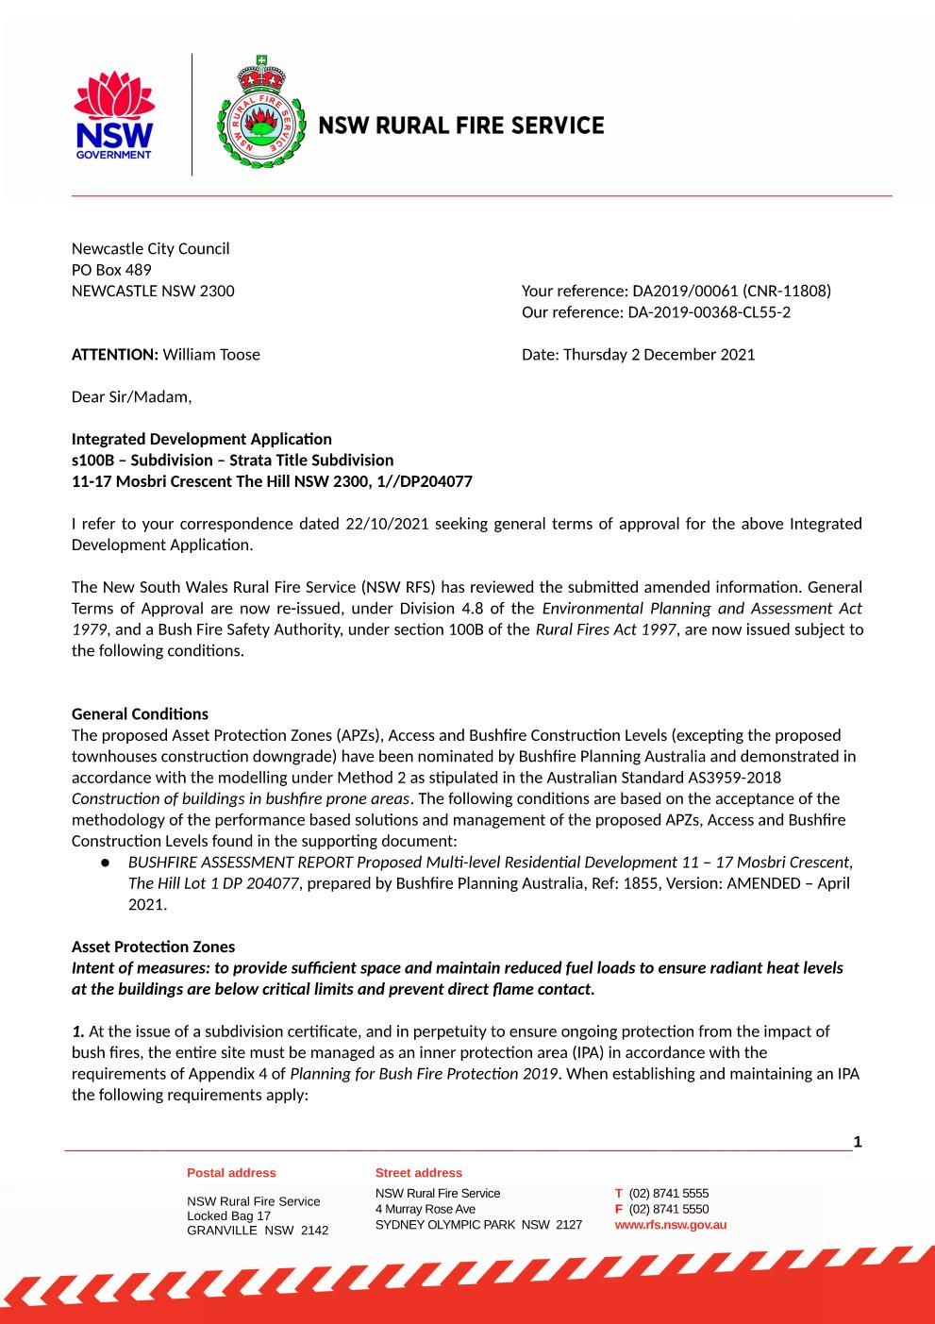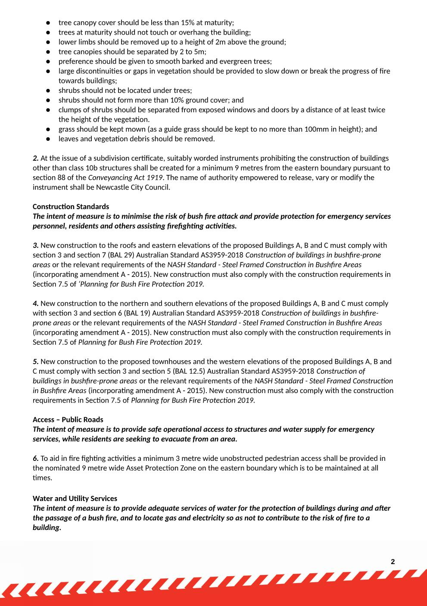



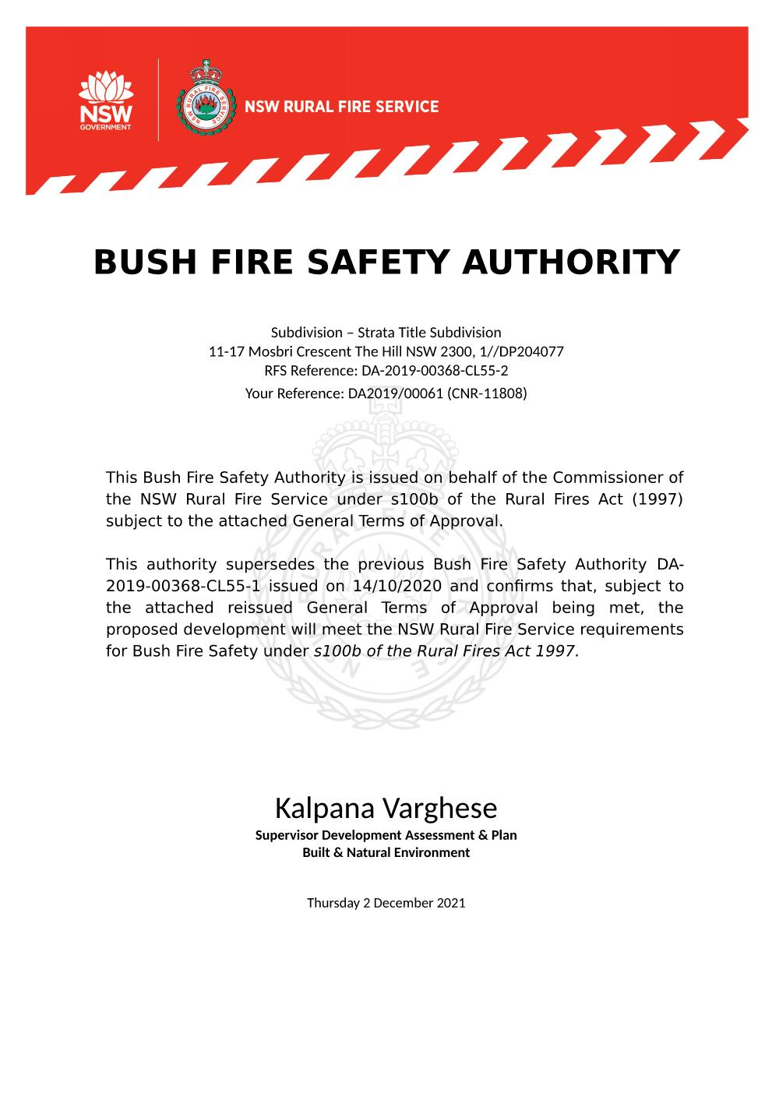

**SCHEDULE 3 SUBSIDENCE ADVISORY NSW GENERAL TERMS OF APPROVAL**

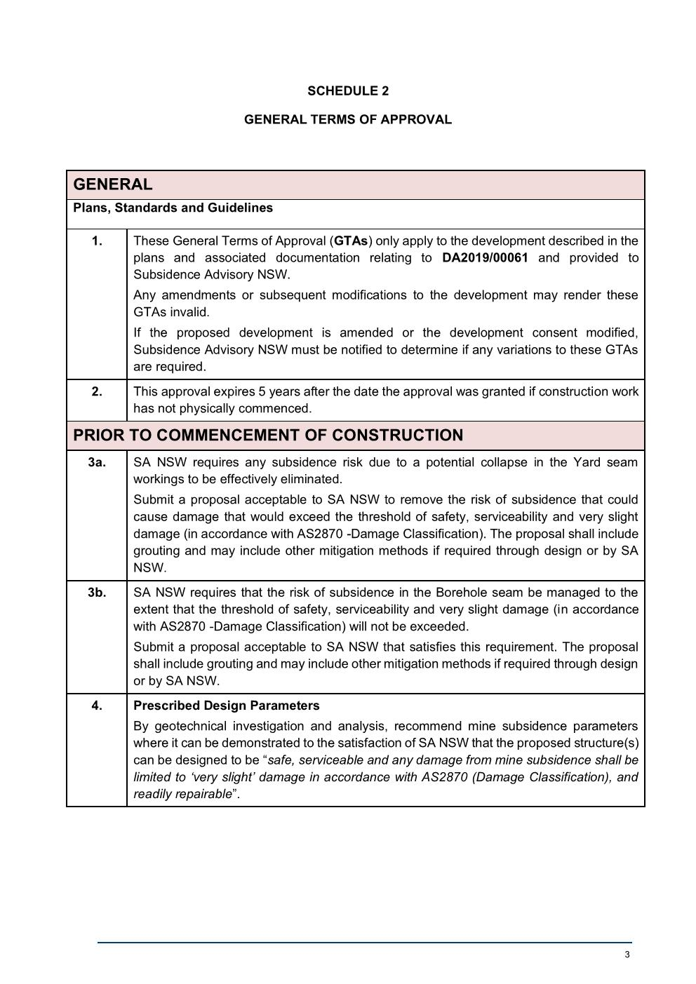

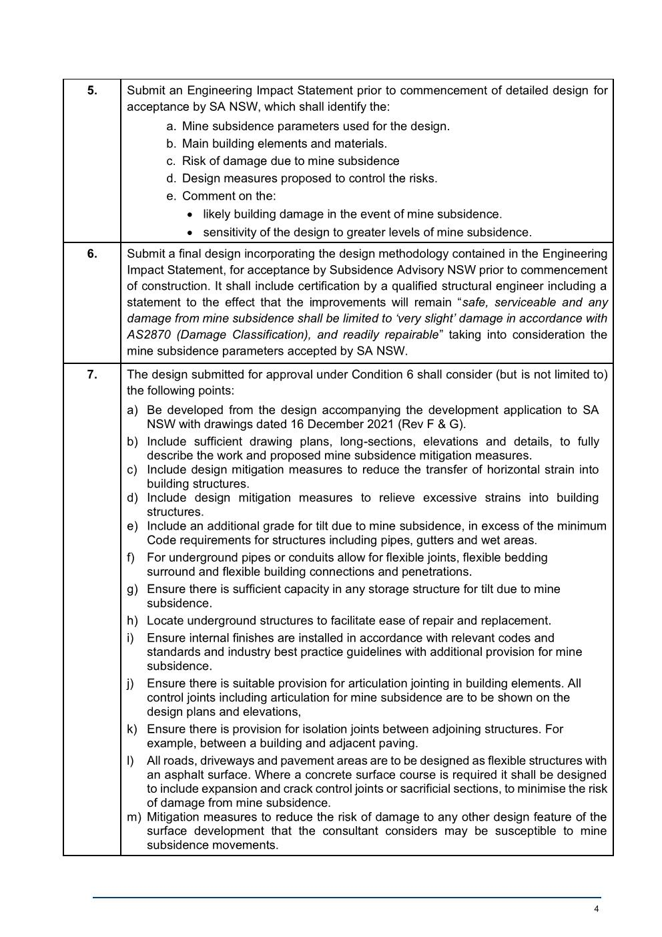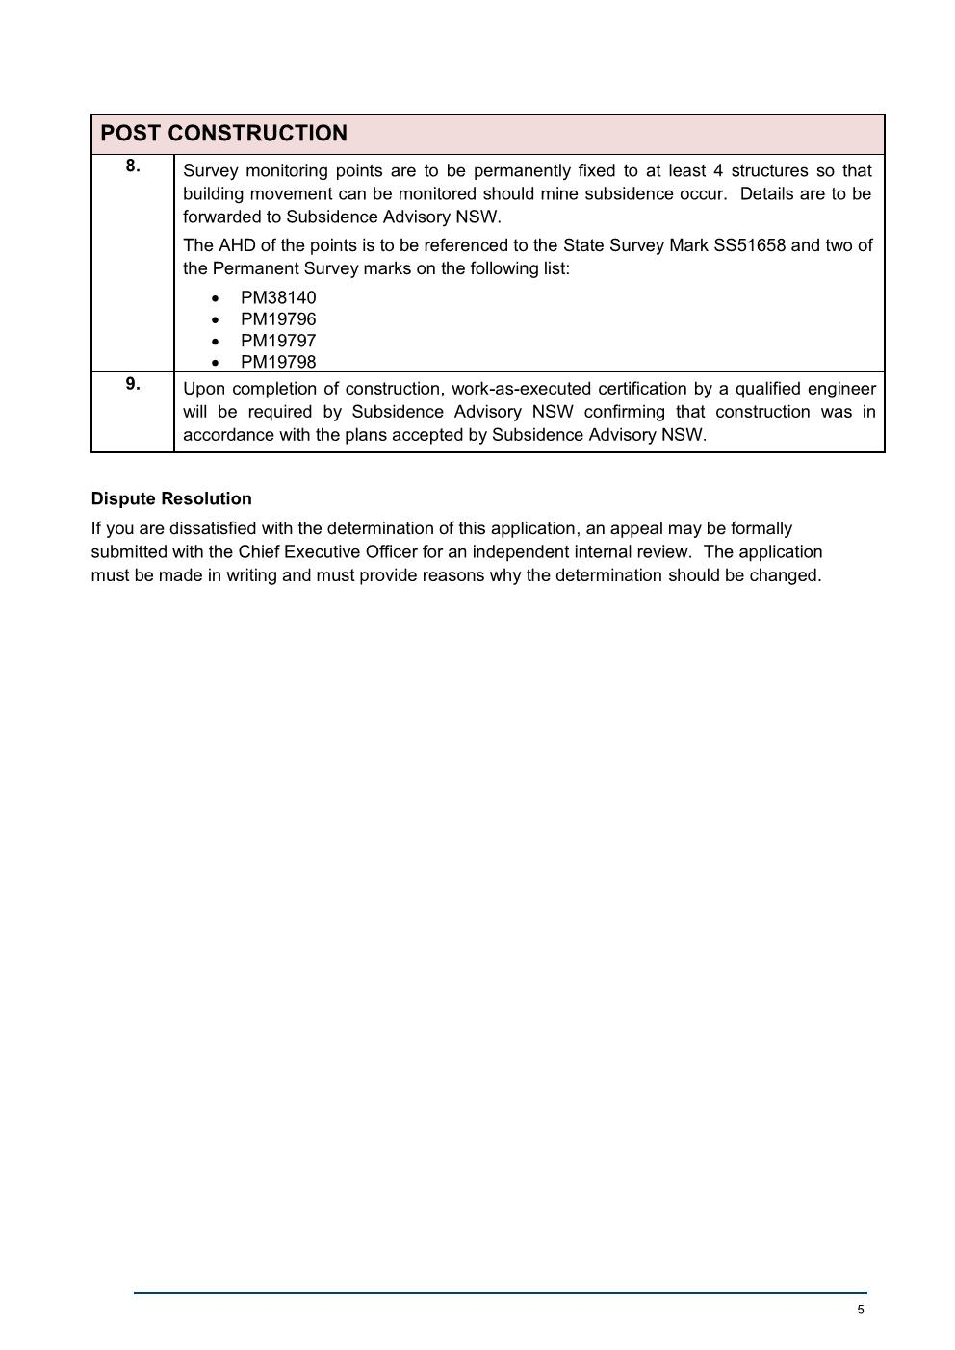

**SCHEDULE 4 HERITAGE NSW GENERAL TERMS OF APPROVAL**

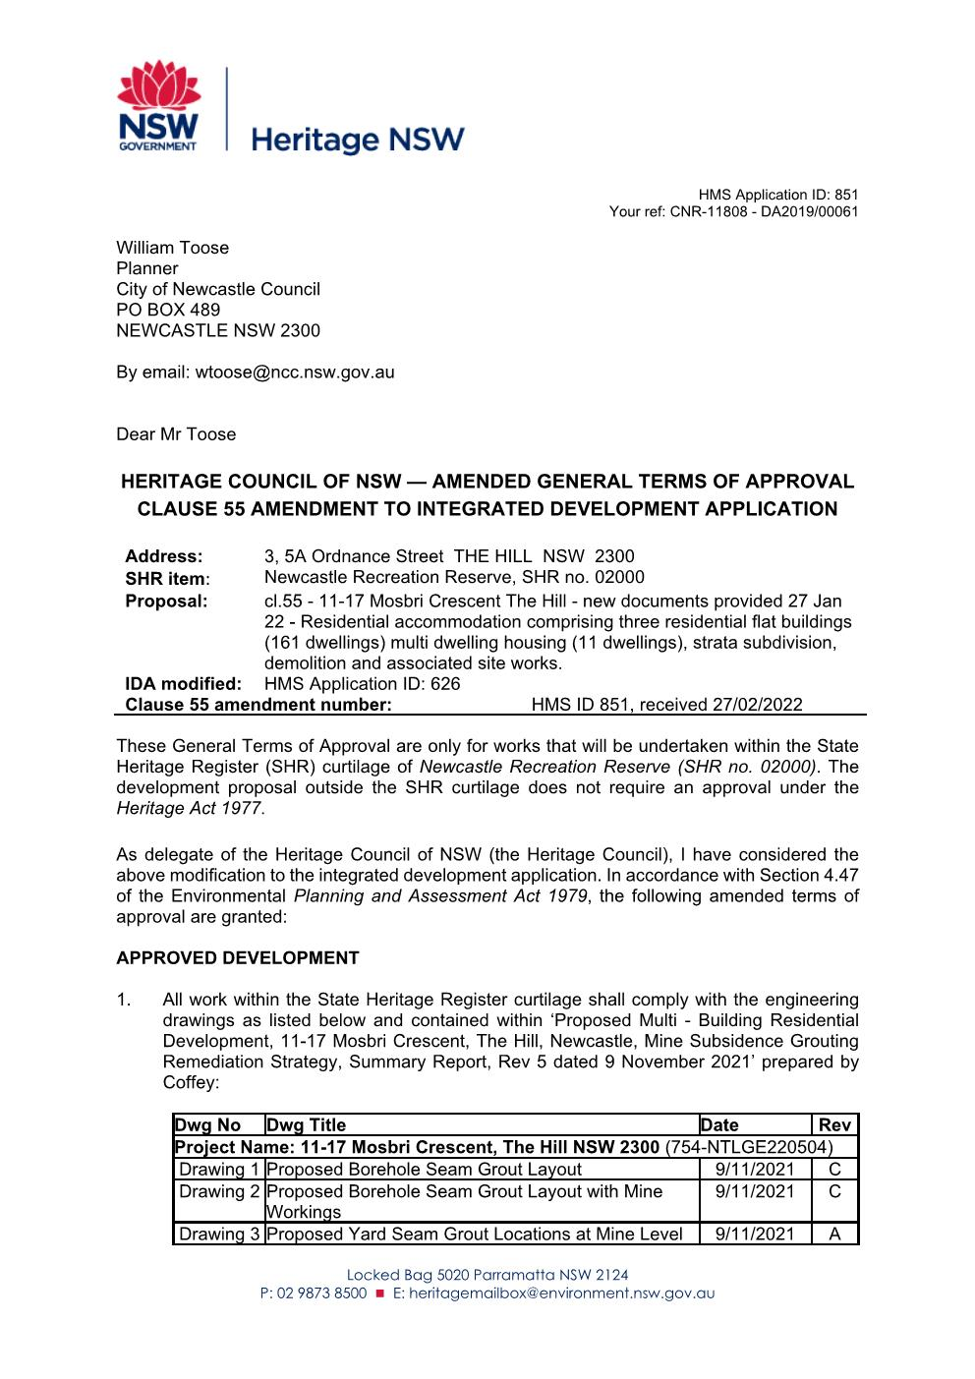

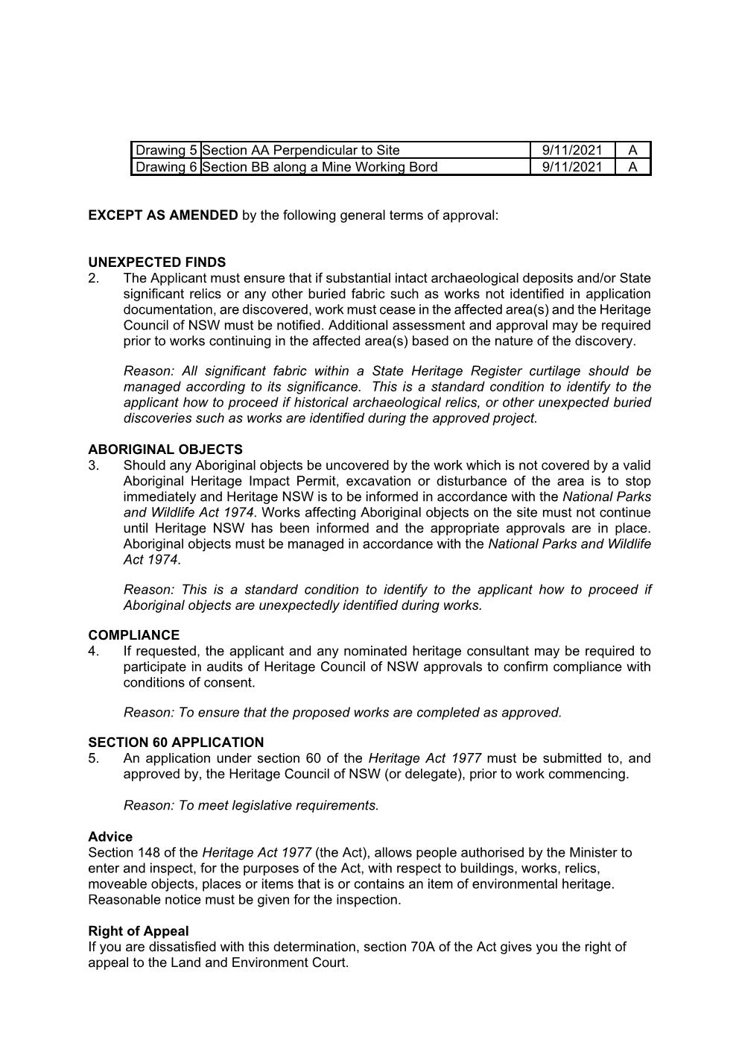

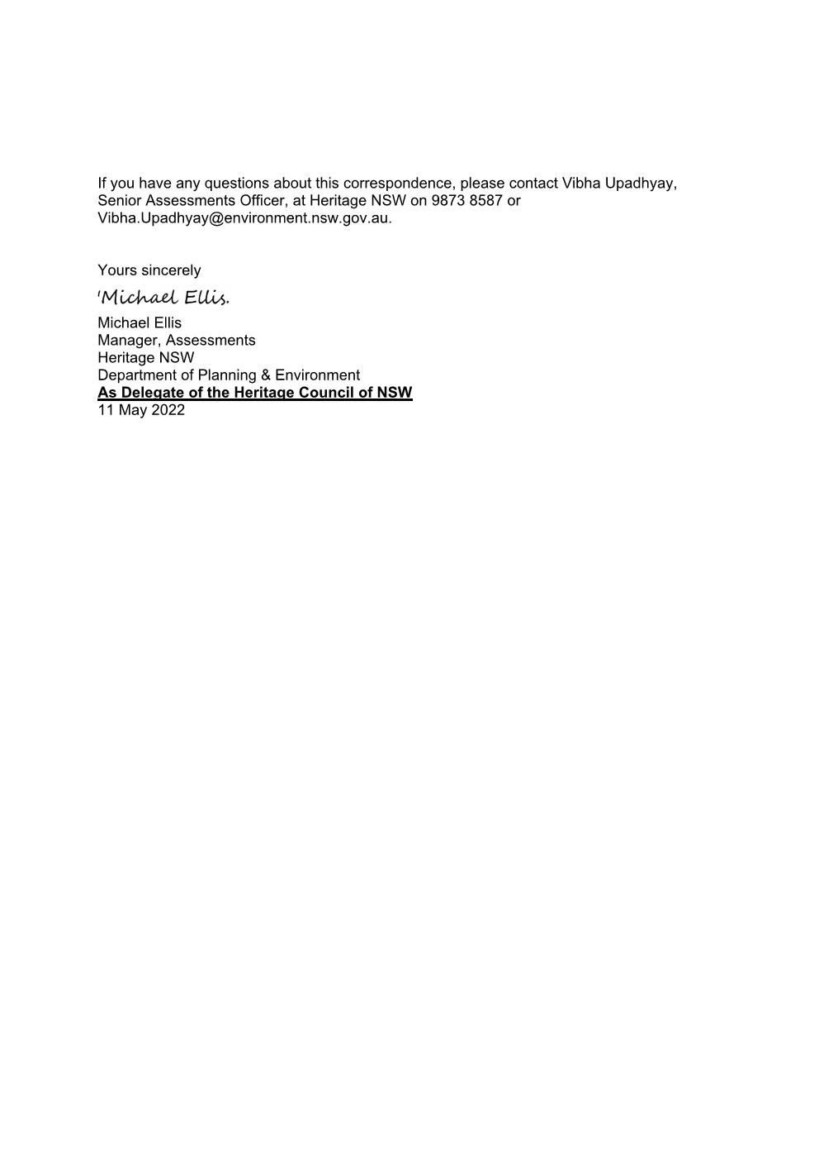

**END OF CONDITIONS**